Report on site visit to Oloolua Forest to range test LoRa communication module

Abstract

In response to the need for reliable long-range communication in remote forested areas, this report presents findings from a site visit to Oloolua Forest aimed at range testing a LoRa communication module transmitting and receiving SNR and RSSI data provided by a sensor node connected at the transmitter. The background of this study stems from the necessity to establish robust communication infrastructures in the given environment where alternative methods such as GSM are likely to be costly and summatively inefficient.

The experiment overview details the setup of LoRa communication modules within Oloolua Forest, a dense and dynamic ecosystem. By strategically placing nodes at various distances and terrain types, we aimed to assess the effective range and reliability of LoRa technology in such conditions. Through systematic data collection and analysis, the experiment aimed to provide insights into the feasibility of utilising LoRa for communication purposes in similar environments.

Results indicate promising outcomes, showcasing the capability of LoRa technology to maintain reliable communication over considerable distances, even in densely forested areas. The data reveals the module's resilience to environmental obstacles to some degree, with relatively consistent signal strength observed across diverse terrains within the forest. It was observed that the modules had a range of about 280m and 425m in different directions.

This study's potential impact extends to various sectors, including environmental monitoring, wildlife conservation, and emergency response. By demonstrating the viability of LoRa communication in such challenging terrains, this research opens avenues for enhancing communication networks in remote regions, thereby facilitating improved data collection, surveillance, and crisis management as shall be in use in a larger project regarding illegal logging in forests.

In conclusion, the findings underscore the efficacy of LoRa technology in enabling robust communication infrastructures in challenging environments, with implications for various fields requiring remote connectivity and data transmission.

1. Introduction

1.1 Purpose of the visit
The primary objective of the visit to Oloolua Forest was to conduct a comprehensive range test of LoRa (Long Range) communication modules. Given the demand for reliable long-range communication solutions in remote and challenging environments, a forest in our case, it became imperative to assess the feasibility and effectiveness of LoRa technology within such settings. The visit aimed to gather empirical data regarding the performance of LoRa modules in Oloolua Forest, a dense and diverse ecosystem, to inform potential applications in environmental monitoring for the illegal logging taking place in forests.

1.2 Background information
Oloolua Forest, located in the Karen neighbourhood, Nairobi, represents a unique ecosystem characterised by dense vegetation and high tree lines, undulating rugged terrain, and limited access to traditional communication infrastructure. This environment poses significant challenges for establishing reliable communication networks, hindering activities such as data collection, surveillance, and emergency response efforts. The need for resilient and long-range communication solutions in such environments prompted the exploration of LoRa technology, known for its low-power, wide-area networking capabilities.

1.3 Problem areas
The visit aimed to address several key challenges associated with communication in remote and inaccessible areas which are hotbeds for illegal logging. These challenges include limited network coverage, susceptibility to environmental interference given the densely forested environment, and the high cost of deploying and maintaining traditional communication infrastructures such as GSM. By identifying and assessing these problem areas within Oloolua Forest, the visit sought to propose viable solutions leveraging LoRa technology.

1.4 Literature review
LoRaWAN (Long Range Wide Area Network) technology offers a compelling solution for long-range, low-power communication in IoT (Internet of Things) applications. It is particularly well-suited for environments where traditional cellular networks face limitations, such as remote or densely forested areas.

Technical Underpinnings:
Chirp Spread Spectrum (CSS): LoRaWAN uses CSS modulation to spread signals across a wide frequency range, enabling robust communication over long distances. This modulation technique enhances signal resilience against interference and multipath fading, making LoRaWAN ideal for challenging environments like forests.

Adaptive Data Rate (ADR): A key feature of LoRaWAN is its adaptive data rate mechanism, which dynamically adjusts transmission parameters based on environmental conditions. This optimization ensures efficient use of network resources and extends the reach of communication in varying terrain.

Signal Quality Metrics:
Signal-to-Noise Ratio (SNR): SNR measures the strength of the received signal relative to background noise. Higher SNR values indicate clearer signal reception and reduced susceptibility to interference, which is crucial for maintaining reliable communication in forested areas.

Received Signal Strength Indication (RSSI): RSSI quantifies the strength of the received signal at the receiver's antenna. Monitoring RSSI values helps assess signal propagation and coverage, providing insights into the effective range of communication.

Applications in Forest Monitoring:
LoRaWAN technology holds promise for monitoring environmental conditions and detecting activities like illegal logging in forested areas. By leveraging its long-range capabilities and adaptive transmission features, LoRaWAN enables the deployment of sensor networks for real-time data collection and analysis over vast forest expanses.

1.5 Objectives of the report
The report aims to document the findings and outcomes of the site visit to Oloolua Forest, presenting a comprehensive analysis of the range test conducted on LoRa communication modules. Specifically, the report seeks to evaluate the performance of LoRa technology in challenging environments that are reminiscent of the forests that the illegal logging monitors are to be set up. Additionally, recommendations for future research and implementation strategies based on the inferences garnered from the research have been proposed.

2. Methodology

2.1 Selection of the test location
The selection of Oloolua Forest as the test location was based on several factors, including its dense vegetation, rugged terrain, and limited access to traditional communication infrastructure. These characteristics align with the target environment for assessing the performance of LoRa communication modules in similarly challenging conditions. Additionally, Oloolua Forest provided diverse topographical features, allowing for a comprehensive range test across various terrains.

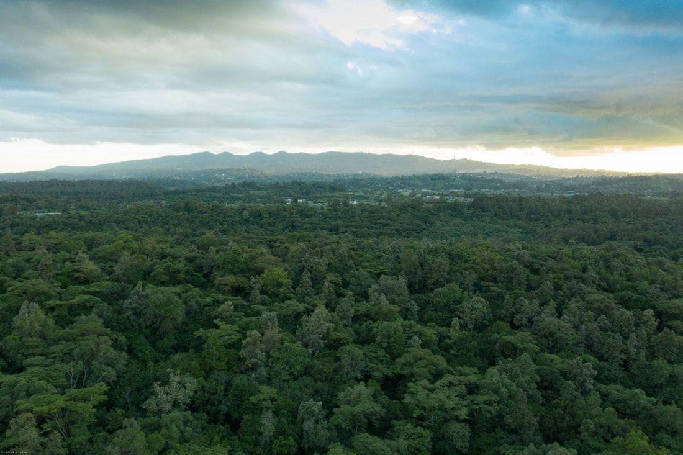

2.2 Setup of the LoRa communication module
The setup of the LoRa communication module involved several steps to ensure optimal performance and data collection. First, a base station was established at a centrally located point within Oloolua Forest, equipped with a high-gain antenna for improved signal reception. Satellite positioning systems were utilised to precisely determine the coordinates of the base station, facilitating accurate distance measurements during the range test.

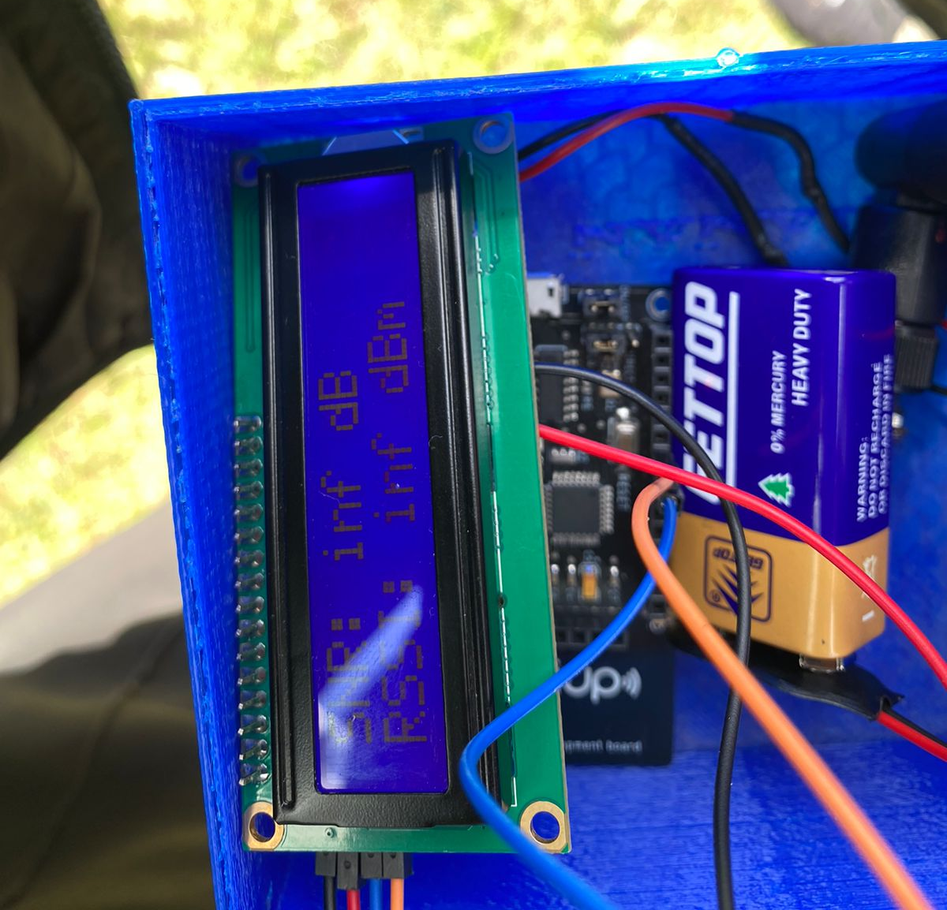

Next, LoRa nodes were strategically deployed at predetermined locations throughout the forest, covering a range of distances and terrain types. Each node was configured to transmit periodic signals to the base station, utilising LoRa's low-power, wide-area networking capabilities. The nodes were equipped with environmental sensors to monitor factors such as sound intensity and estimated distance providing additional data for analysis.
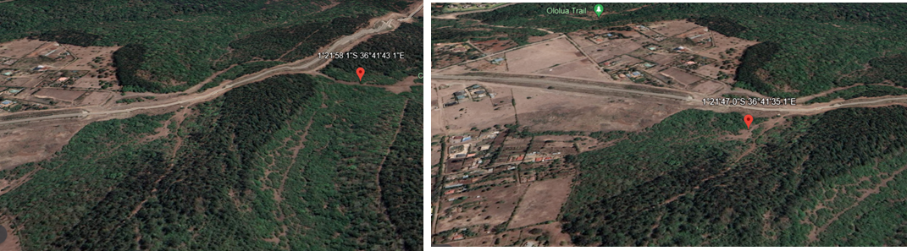

2.3 Data collection process
Data collection commenced following the setup of the LoRa communication module. The base station continuously transmitted signals to the deployed node, indicating received signal strength indicator, signal to noise ratio, sound intensity and estimated distance at regular intervals and an “OUT OF RANGE” indication when the receiver was effectively out of range. Periodic inspections were conducted to ensure the proper functioning of the nodes and address any technical issues that arose during the testing period.

Additionally, GPS-enabled devices were used to track the locations of field technicians and verify the accuracy of distance measurements between the nodes and the base station. This comprehensive data collection process enabled a thorough analysis of the performance of the LoRa communication modules across different distances and environmental conditions within Oloolua Forest.

3. Findings

3.1 Range test results
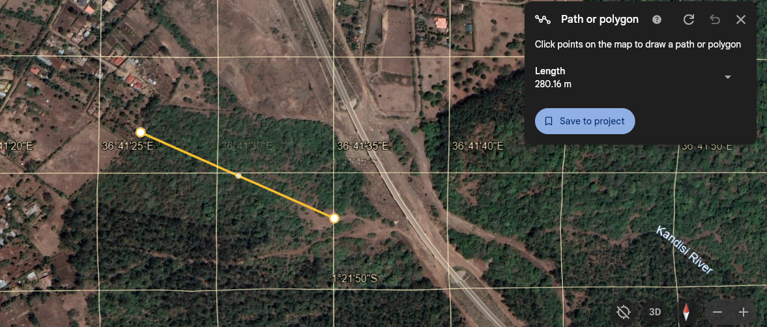
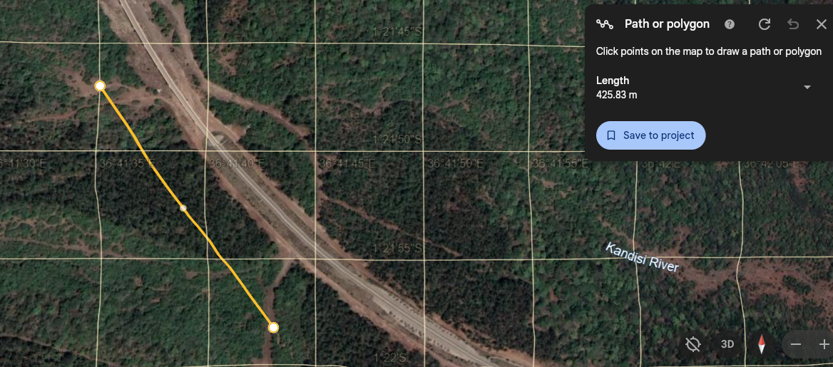

3.2 Signal strength analysis
 | Location | SNR | Distance from stationary point [metres (m)]
Direction A | -1.3631374, 36.6923560 | -19.14 | 81.21
Direction A | -1.3626866, 36.6920532 | -51.96 | 120.83
Direction A | -1.3619529, 36.6918547 | -21.65 | 182.29
Direction A | -1.3619360, 36.6913750 | -25.11 | 225.97
Direction A | -1.3621409, 36.6907849 | -64 | 274.14
Direction B | -1.3630309, 36.6932085 | -35.7 | 14.31
Direction B | -1.3623963, 36.6925113 | -42.42 | 95.69
Direction B | -1.3632845, 36.6941764 | -34.46 | 124.79
Direction B | -1.3636486, 36.6943463 | -47.1 | 156.06
Direction B | -1.3644557, 36.6948951 | -50.02 | 255.75
Direction B | -1.3652252, 36.6954776 | -57.98 | 360.48
Direction B | -1.3661375, 36.6952998 | Out of range | 423.49

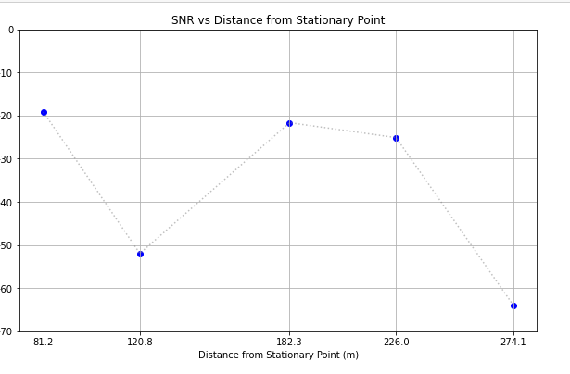
- The SNR values obtained from the recorded data indicate the strength of the received signal relative to the background noise levels.
- Locations closer to the stationary point generally exhibited higher SNR values, indicating better signal quality and less interference.
- For instance, at 81.21 metres from the stationary point, the SNR was measured at -19.14 dB, suggesting relatively clear signal reception.
- However, as the distance from the stationary point increased, SNR values tended to decrease, indicating a weakening of the signal and increased susceptibility to noise interference.
- Notably, at farther distances, such as 423.49 metres, the SNR dropped below acceptable levels, rendering the signal unusable for communication purposes.

3.3 Environmental factors affecting communication
The variation in transmission range observed during the experiment can be attributed to several environmental factors, including terrain, vegetation density, and line-of-sight obstructions. In areas characterised by obstructed paths or dense vegetation, the transmission range was notably shorter compared to open areas with clearer line-of-sight paths.

Terrain plays a significant role in signal propagation, with rugged landscapes and elevated terrain potentially obstructing signal paths and causing signal attenuation. Dense vegetation further exacerbates this effect by absorbing and scattering radio waves, reducing the effective range of communication. In contrast, locations with clear line-of-sight paths experience minimal signal interference and offer better transmission range.

These findings underscore the importance of considering environmental factors when designing and deploying LoRaWAN networks in forest environments. Strategic node placement and network optimization are essential for overcoming signal propagation challenges and ensuring reliable communication coverage across diverse terrain types. By addressing these factors,we can maximise the effectiveness of forest monitoring systems and enhance conservation efforts.

3.4 Comparison with expected performance
Anticipated Performance:
In ideal conditions, LoRaWAN technology is capable of achieving transmission ranges of up to 7 kilometres, particularly in environments with minimal obstructions and interference.
The optimal Signal-to-Noise Ratio (SNR) range for reliable communication typically falls between 18 to 30 decibels (dB). A minimum SNR value of 18 dB is considered essential for maintaining relatively optimal performance, with values below this threshold significantly compromising system reliability.

Observed Performance:

The observed transmission ranges and SNR values in the Oloolua Forest varied based on environmental factors such as terrain, vegetation density, and line-of-sight obstructions.
Locations characterised by obstructed paths or dense vegetation tended to exhibit shorter transmission ranges compared to open areas with clearer line-of-sight paths.

SNR values fluctuated across different distances from the stationary node, with some locations experiencing negative SNR values indicative of excessive noise relative to the desired signal.
The recorded SNR values ranged from -64 dB to -19.14 dB, reflecting the varying levels of noise interference encountered during the experiment.

Discrepancies and Considerations:
The observed performance of LoRaWAN communication modules in the forest environment deviated from the anticipated ideal conditions, highlighting the impact of real-world factors on system operation.
Environmental variables such as terrain topology, foliage density, and atmospheric conditions influenced signal propagation and reception, leading to deviations from expected transmission ranges and SNR values.
Negative SNR values recorded at certain locations underscored the presence of significant noise interference, challenging the reliability of communication in those areas.

4. Conclusion and Recommendations

4.1 Summary of findings
The range test conducted on LoRa communication modules within Oloolua Forest has provided valuable insights into their performance in challenging environmental conditions. The results demonstrate the feasibility of utilising LoRa technology for establishing reliable communication networks in remote and inaccessible areas. Despite the dense vegetation and rugged terrain, the modules maintained consistent signal strength and transmission rates across various distances within the forest.

4.2 Implications for future deployments
The findings of this study have significant implications for future deployments of communication systems in similar environments. LoRa technology offers a cost-effective and scalable solution for addressing the communication challenges associated with remote locations. By leveraging LoRa's long-range capabilities and low-power consumption, organisations and agencies can enhance their capacity for data collection, environmental monitoring, and emergency response in areas with limited connectivity.

4.3 Recommendations for improvement
To further improve the effectiveness and efficiency of LoRa deployments in challenging environments, several recommendations are proposed:

- Optimization of Node Placement: Future deployments should consider optimising the placement of LoRa nodes to maximise coverage and minimise signal interference. Conducting a thorough site survey and employing advanced modelling techniques can aid in identifying optimal node locations.

- Integration of Redundancy: Incorporating redundancy mechanisms into communication networks can enhance reliability and resilience against signal disruptions or node failures. Implementing redundant nodes and employing mesh networking protocols can mitigate the impact of environmental obstacles on communication performance.

- Enhancement of Environmental Sensors: Integrating advanced environmental sensors into LoRa nodes can provide more comprehensive data for monitoring and analysis purposes. Sensors capable of measuring additional parameters such as soil moisture, sound levels, and wildlife activity can further expand the potential applications of LoRa technology in environmental research and conservation efforts.

By addressing these recommendations, future deployments of LoRa communication systems can better meet the communication needs of remote and challenging environments, paving the way for improved connectivity and data-driven decision-making in these areas.

5. References
- Oloolua Forest. (n.d.). The Oloolua Forest. Retrieved April 15, 2024, from http://www.olooluaforest.com/

